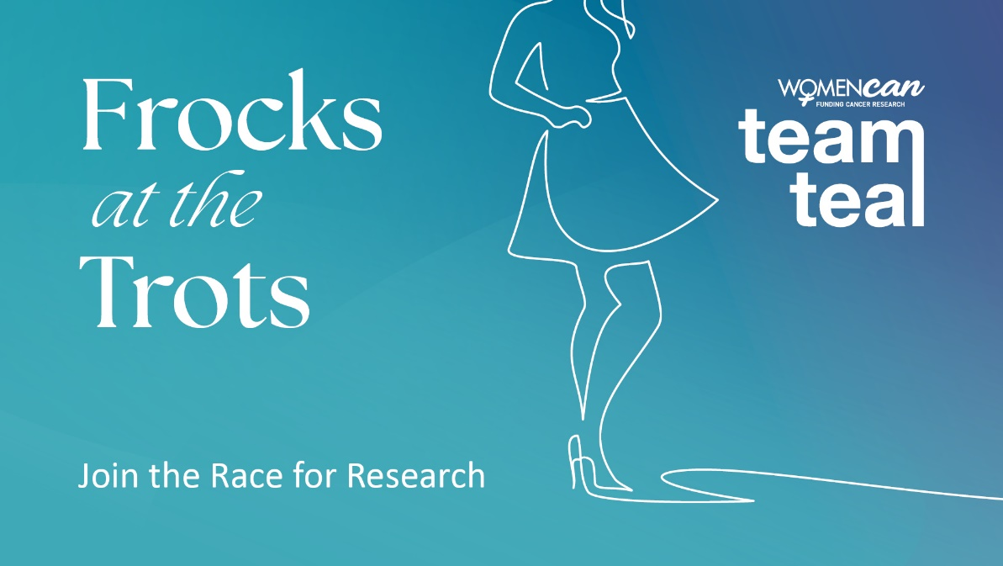
FOR IMMEDIATE RELEASE
Get ready for an unforgettable night of glamour, speed, and impact at Team Teal Frocks at the Trots!
[Your Club] is excited to announce the launch of Team Teal Frocks at Trots. It’s a [day/night] filled with fundRACING, fashion, and food. This spectacular event will be held on [Event date] and promises to be an exciting [day/evening], all while raising funds for ovarian and gynaecological cancer education and research.
What to expect on this unmissable [day/night]
- Fashion on the Field - Strut your stuff and showcase your style in our glamorous Fashion on the Field competition, where every step contributes to the fight against ovarian and gynaecological cancer.
- Raffles and prizes - Get ready for heart-pounding excitement with enticing raffles and fantastic prizes up for grabs, all in support of WomenCan.
- Teal meal deal - Indulge your taste buds in our delectable Teal Meal Deal, where every bite supports the crucial cause of gynaecological cancer research.
- Teal cocktail - Sip on our exclusive Teal Cocktail – a tantalising concoction crafted for a cause. A portion of every sip goes towards WomenCan.
- Merchandise - Dive into a sea of teal with exclusive Team Teal merchandise, including must-have tiaras, feather boas, teal tattoos, and more – wear your support in style!
- Live music - Feel the rhythm and let loose as live music sets the stage for an unforgettable atmosphere of celebration and camaraderie.
- [Please add or remove from the above list depending on your fundraising]
Event details:
Date: [event date]
Time: [event time]
Location: [event location]
[Include relevant information about where to buy tickets, parking etc]

What is Team Teal?
Team Teal is an initiative of WomenCan, a not-for-profit organisation raising funds for crucial gynaecological cancer research and prevention & education programs through the Australia New Zealand Gynaecological Oncology Group (ANZGOG).
Every day in Australia and New Zealand 22 women are diagnosed with a gynaecological cancer. And for ovarian cancer the five-year survival rate is 49% for Australian women and 38% for New Zealand women. Team Teal raises funds and awareness for women with ovarian and other gynaecological cancers, through celebrating women’s achievements in sport. Our vision is to advance research and save lives. Each year Harness Racing supports WomenCan’s Team Teal initiative with female drivers wearing Teal Pants for awareness and with donations made by the industry, TAB & Clubs for every win by a female driver or trainer from 1 Feb – 15 March every year. Teal is the international colour symbolising ovarian cancer.
Join us for Team Teal Frocks at the Trots where speed meets style, and every moment makes a difference. Let's race towards a brighter, teal-tinted future together!
Visit the Team Teal website for more information: www.teamteal.org.au

For Media Inquiries, Please Contact:
[Your Contact Name]
[Your Contact Title]
[Your Contact Email]
[Your Contact Phone]

[Club Name]
[Club Address]
[Club Website]
[Club Social Media Handles]

